Data Analytics (DA)
Module -4
Python Assignment 1 - Data Structures - Strings & Tuples
Problem Statement:
This assignment focuses on understanding Python string operations and tuple manipulation, including concatenation, slicing, built-in methods, and tuple operations.

Tasks:
Strings (Concatenation, Slicing, and Other Methods) :
1. String Concatenation:
Write a Python program that takes two strings, i.e., string 1 "Hello" and string 2 “get
name” as input from the user, and concatenates them together. Display the
concatenated string as the output.
OUTPUT:
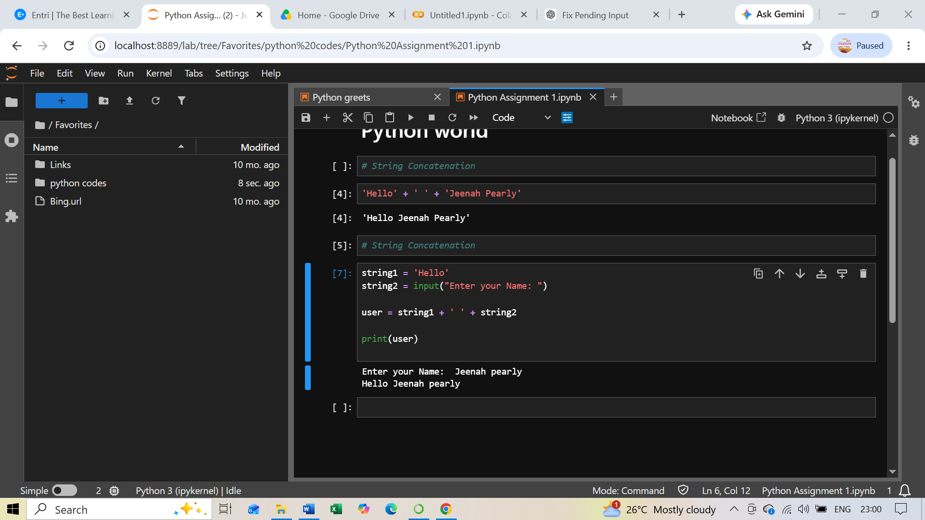
Now, concatenate string 3, "Welcome to Python programming,” to the existing string
and display the output string.
OUTPUT:
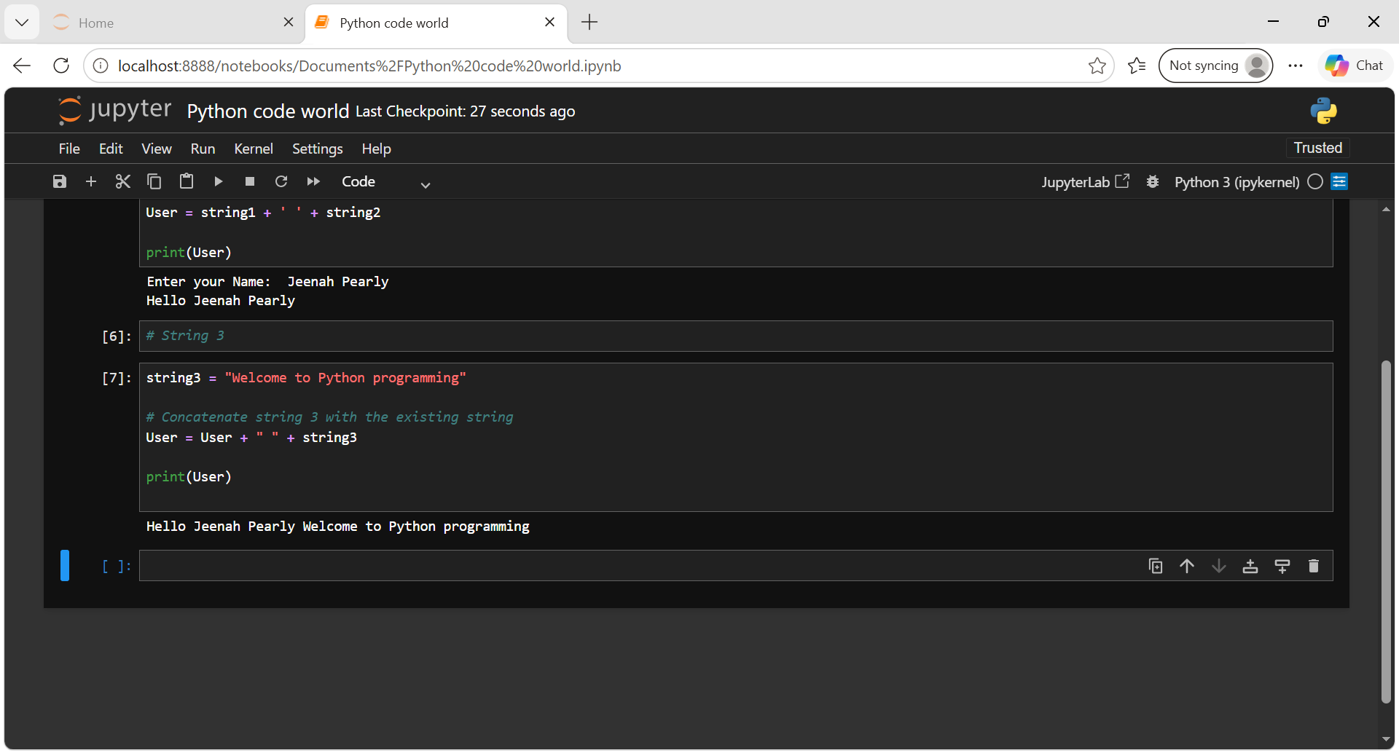

2. String Slicing and Indexing:
Write a Python program using the above concatenated string as input and perform
the following tasks:
a. Print the first character of the string.
b. Print the last character of the string.
c. Print the first 5 characters of the string.
d. Print the last 11 characters of the string.
e. Print the string in reverse.
f. Use slicing and print the word “Python” from the existing string.
OUTPUT:

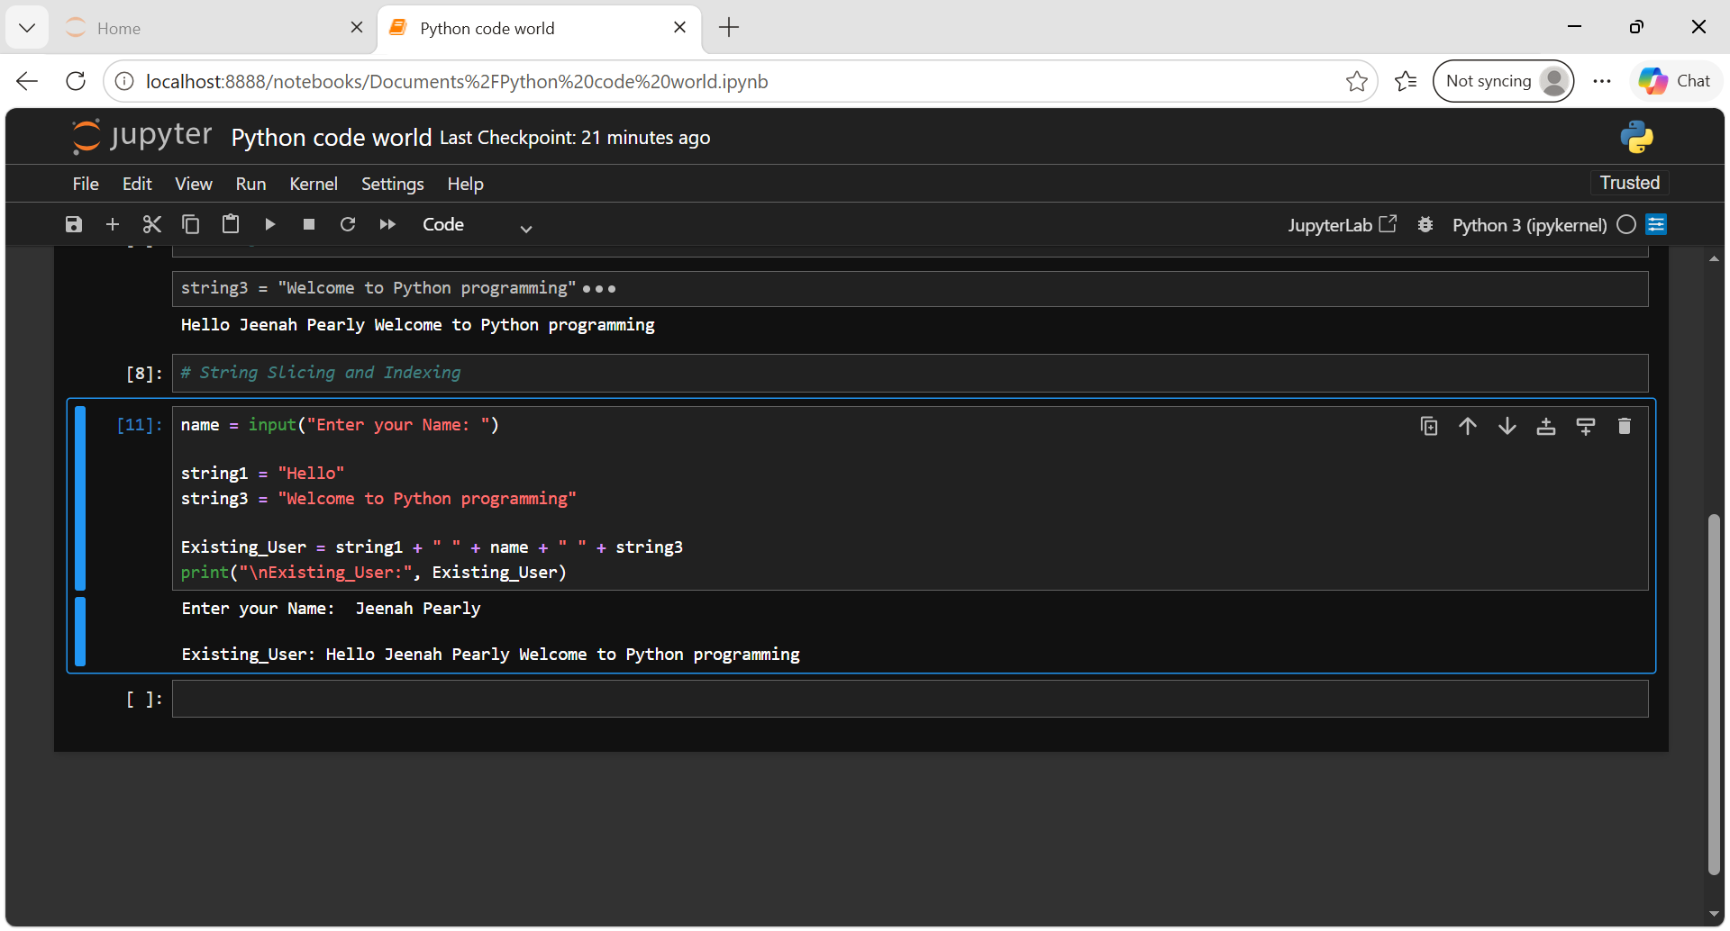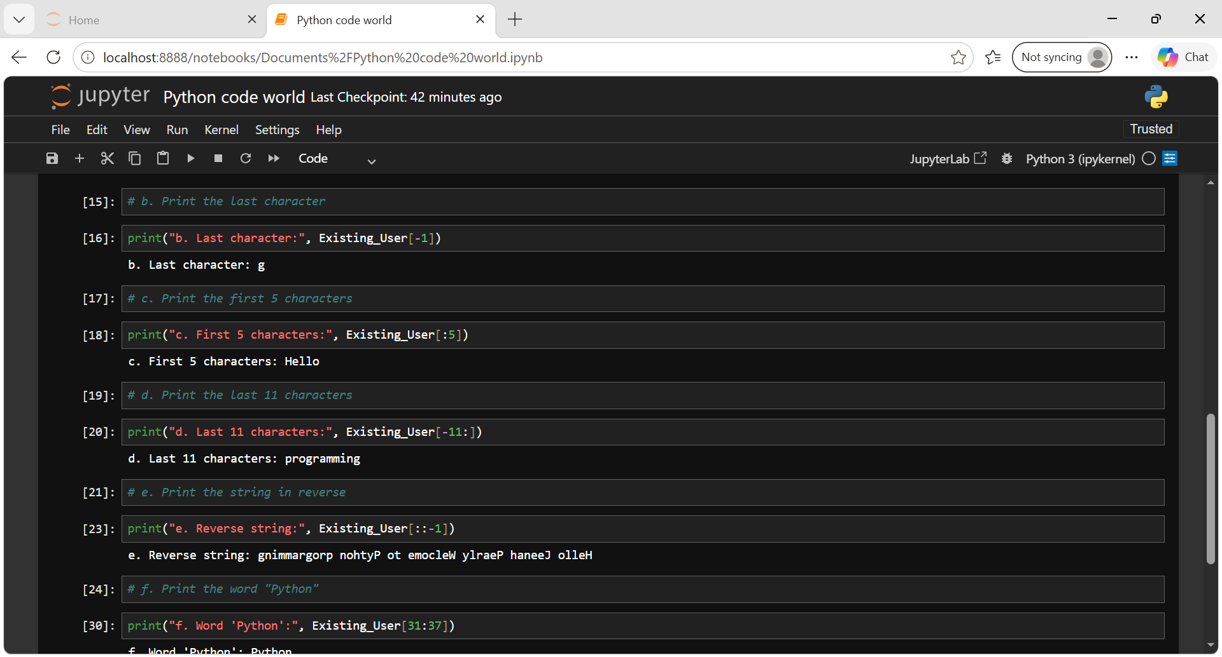

3. String Methods:
Write a Python program that takes a string, strM = “Python beginner tutorial," and
performs the following tasks:
a. Convert the sentence to uppercase.
b. Convert the sentence to lowercase.
c. Use Capitalize and return the sentence to the original input form.
d. Count the total number of occurrences of character ‘t’ in the string.
e. Replace all occurrences of “Python” with “Data Analytics” in the input string
strM = “Python beginner tutorial.”
OUTPUT:
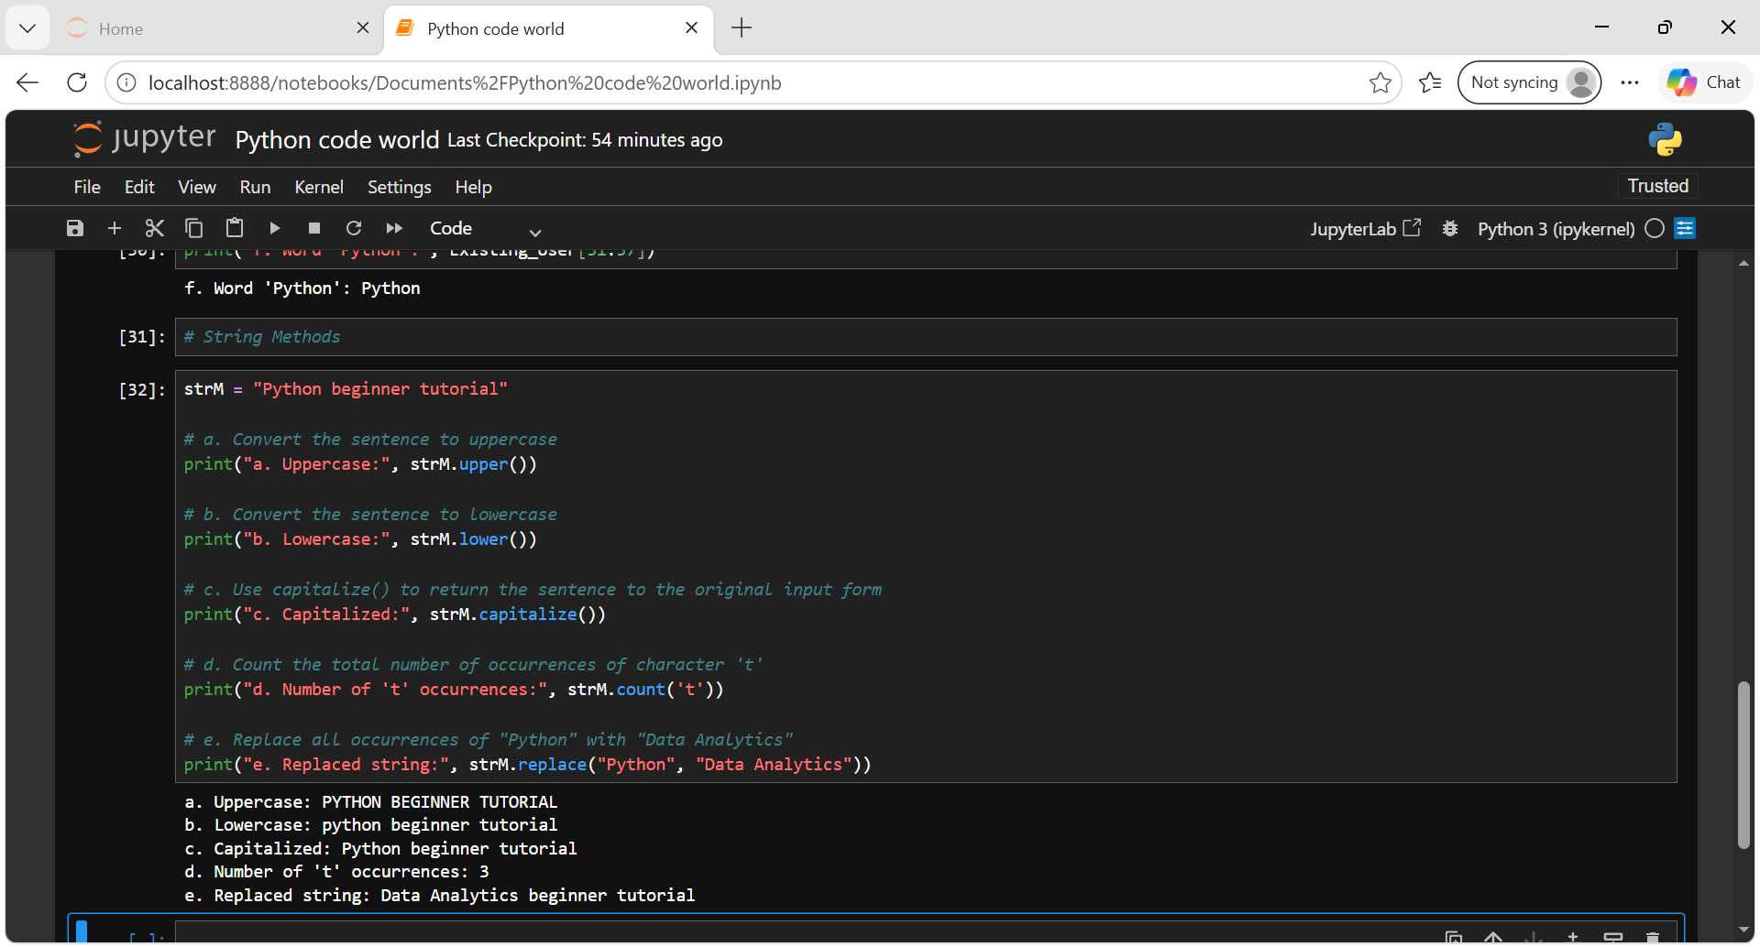

Tuples (Creation, Modification and Access) :
Create the 1st tuple with values -> (10, 20, 30) and the 2nd tuple with values -> (40, 50, 60):
a. Concatenate the two tuples and store it in “t_combine”
b. Repeat the elements of “t_combine” 3 times
c. Access the 3rd element from “t_combine”
d. Access the first three elements from “t_combine”
e. Access the last three elements from “t_combine”
OUTPUT:
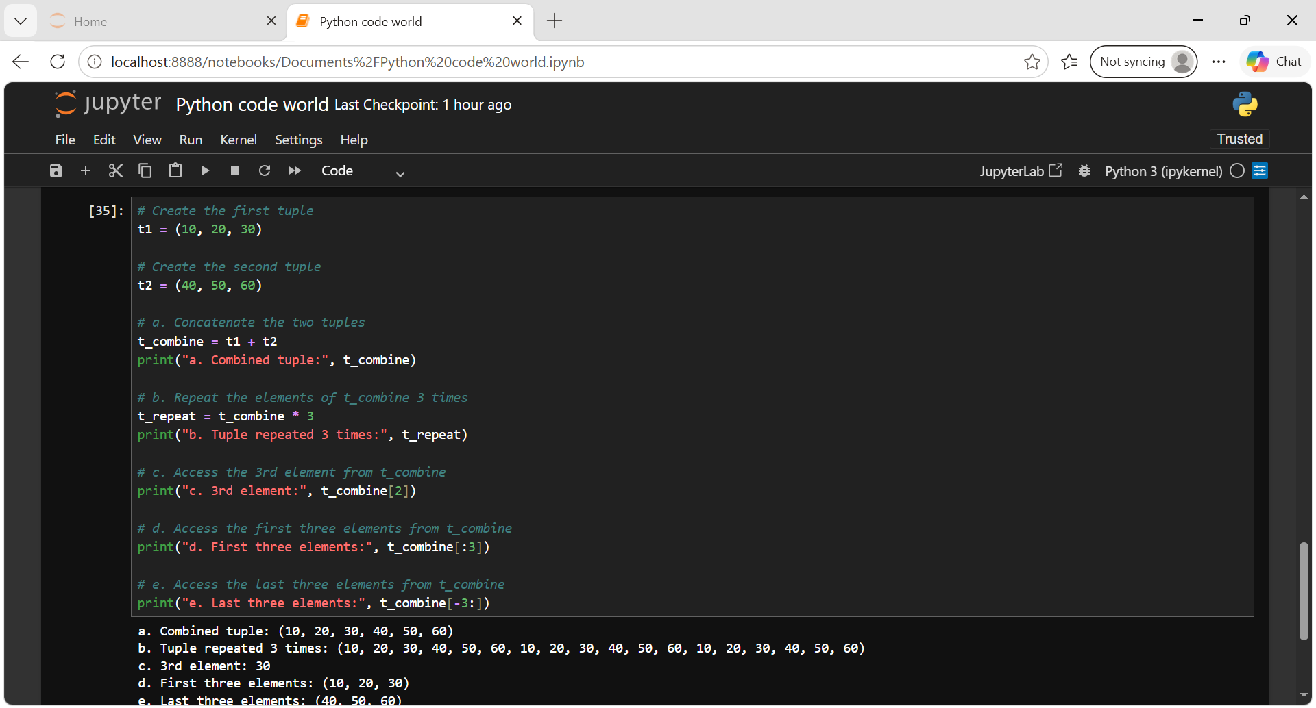

Conclusion: This assignment provided a practical understanding of Python string operations and tuple manipulation. Through string concatenation, indexing, slicing, and built-in string methods, I learned how to create, modify, access, and process string data efficiently. The tuple operations helped me understand tuple creation, concatenation, repetition, indexing, and slicing. Overall, these exercises strengthened my understanding of Python data structures and provided a foundation for working with data effectively in Python.

